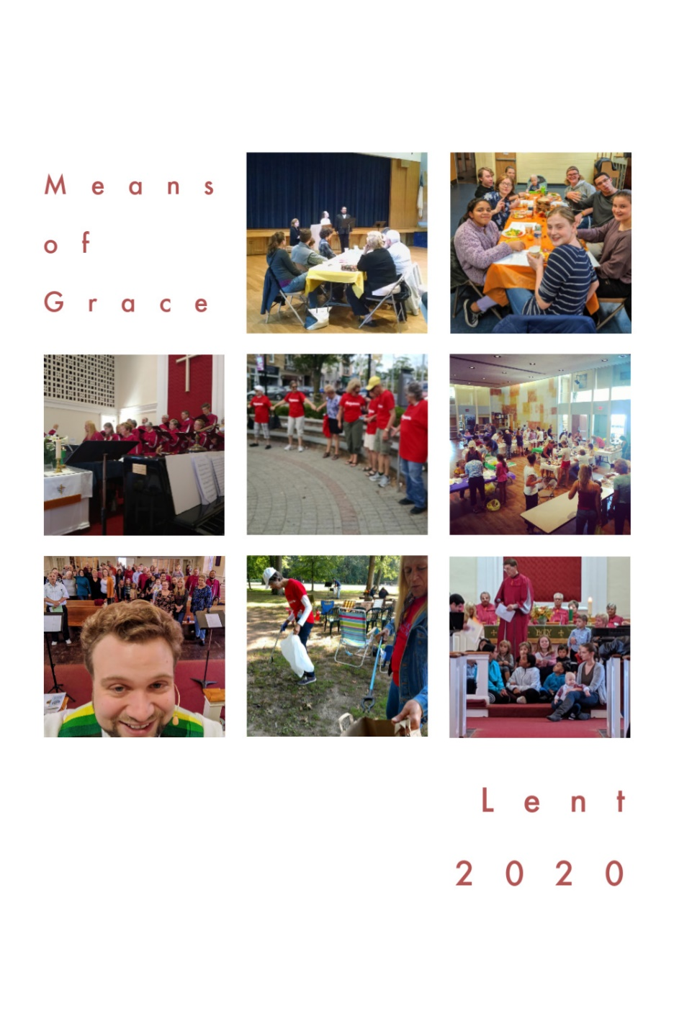

Week 4

What are “Means of Grace?”
John Wesley taught that God's grace is unearned and that we are not to be idle waiting to experience grace but we are to engage in the means of grace. The means of grace are ways God works invisibly in disciples, hastening, strengthening, and confirming faith so that God's grace pervades in and through disciples. As we look at the means of grace today, they can be divided into works of piety and the works of mercy.
Works of Piety
Individual Practices – reading, meditating and studying the scriptures, prayer, fasting, regularly attending worship, healthy living, and sharing our faith with others
Communal Practices – regularly share in the sacraments, Christian conferencing (accountability to one another), and Bible study
Works of Mercy
Individual Practices - doing good works, visiting the sick, visiting those in prison, feeding the hungry, and giving generously to the needs of others
Communal Practices – seeking justice, ending oppression and discrimination (for instance Wesley challenged Methodists to end slavery), and addressing the needs of the poor You are invited to engage in many of these means of grace during this season of Lent! Each Sunday, be sure to pick up this weekly devotional as we seek to grow more fully in God’s transformational love!

Discover more ways to engage in Lent online!

Weekly reflection videos: www.facebook.com/cranfordumcnj

Lent Photo-A-Day: @cranfordumc on Instagram

Website: www.cranfordumc.com

And, of course, Sundays at 10AM!
Monday: Scripture
Scripture: “O God, you are my God, I seek you, my soul thirsts for you; my flesh faints for you, as in a dry and weary land where there is no water.” – Psalm 63:1
Reflection: These feelings that we experience during our time of social distancing are not new to the human experience. Much of the Old Testament speaks of or remembers times of exile and separation. The Psalms are great because they give voice to real human emotions but tend to find their way back to the God of all faithfulness. Ours souls thirst for many things right now; normalcy, connection, going out to eat, safety, clarity about the future, and much more. It’s okay to say so to God!
Let us pray that God will hydrate us spiritually (and physically) during this time of distancing and illness and uncertainty. The fun thing about this particular Psalm is that it has an answer later in the Bible. Jesus says that he came to be among us to offer us living water and promises that if you drink from it, you will never thirst again. That relationship Christ offers goes even beyond the physical boundaries implemented right now. Jesus is with us in our places. Jesus is with us, no matter what the state of our souls, our hearts, or our minds.
As you find yourself spiritually parched from all of the news and the fear and the isolation, make sure that you take time to spiritually hydrate in prayer, devotion, and worship. We’re here for you in that regard!

Tuesday: Music
Your grace abounds in deepest waters
Your sovereign hand
Will be my guide
Where feet may fail and fear surrounds me
You've never failed and You won't start now
- “Oceans” Hillsong United

This song is one of the favorite contemporary songs in our singing repertoire. It’s a great expression of God’s presence with us in times of uncertainty. It calls back images of Jesus walking on water, inviting Peter to climb out of the boat and to walk toward him. Even in places where our feet may not be able to hold us, God’s hand is there to lead, guide, and catch.
When Peter takes his eyes off of Jesus, fear returns and he quickly begins to sink, but even then, Jesus is there to catch him. We find ourselves in a season in which our physical limitations leave us feeling vulnerable. It is wise to listen to the advice of medical professionals to minimize our risk, and at the same time to fix our eyes on Jesus who beckons us to a place of Grace in the midst of the storm.

Sunday: Worship
We are continuing with our online worship until such a time as larger group gatherings are safe once again. Unfortunately, at the time of writing this (March 19th) we do not have a date for that day.
I am thankful for the opportunity to interact with you online, though it is certainly not the same as being together in person. It is important for us to continue to make connected worship a part of our lives, especially when other parts of life are out of sorts like they are right now. I will continue working with technology to keep us worshipping in a corporate way and to provide a semblance of routine.
Pray for all of the pastors out there. This is a difficult time and many are learning new technologies to connect with their people, thankfully I don’t have quite so high a learning curve, but like our teachers, we are out of our element when we are not together in person.
This Week’s sermon is entitled: “Hello Future: To Easter (and Good Friday)”

Saturday: Prayer
Return, O my soul, to your rest,
for the Lord has dealt bountifully with you…. Psalm 116:7

Longing for connection.
Longing to be not alone.
Longing for what makes life whole.
Longing for love.
Longing for God.

And God’s longing back,
longing for all creation,
for every atom of being.
Longing for love.
Longing for me.

~ written by Margaret D. McGee

Wednesday: Fasting
Well, we are over the half way point in Lent. Did you intentionally give up anything at the start? How is that seasonal fast going? If you have maintained your fast, well done! Have you learned anything about yourself or what role that thing played in your life? I know when I gave up soda a few years ago, it revealed how reliant I had become on substances like sugar and caffeine. I was very cranky without it, and after working through the withdraw, was able to eventually feel better without relying on the substance to provide a false sense of “feeling well.”
If you’ve not kept up with your fast, don’t be down on yourself. This has been an exceptional Lenten season. Instead, try to get at the why in your case as well. Did stress win the day? That’s okay, it’s never too late to make the next prudent decision. Try again and try often to grow! Of course, God’s graceful presence is with you whether you find yourself meeting your goals, or not. There are lessons to learn from every situation.

Thursday: Healthy Living
Here’s something fun for this week. Let us look at some of John Wesley’s health tips and remedies. His book, Primitive Physick, features over 800 remedies for 300 unique ailments!
I’m not as willing to commit to Wesley’s medical recommendations as I am to the denomination he founded. After all, he did suggest rubbing the head with onions and honey to cure baldness and snorting vinegar to reverse a bout of lethargy (certainly would wake you up). Nevertheless, Wesley offered some sound advice about specific areas of health, and in fact, was ahead of his time on certain points. Below are a few of his more helpful tips:
“Water is the wholesomest of all drinks; quickens the appetite, and strengthens the digestion most.”
“A due degree of exercise is indispensably necessary to health and long life.”
“Those who read or write much should learn to do it standing; otherwise it will impair their health.”
For coughs, “make a hole through a lemon and fill it with honey. Roast it, and catch the juice. Take a tea-spoonful of this frequently.”
“Go to bed at 9pm and get up between 4am and 5am.”
Whether or not you follow John Wesley’s advice on how to cure your next headache, I think it’s important to remember the essence of his teachings on health: that “wholeness is the well-working of the body” and that balancing all areas of health is a spiritual process.

Friday: Sharing Faith
This is indeed a season in which we have the opportunity to show the world what it means to love our neighbors well. We have a group of volunteers who are ready to shop for those who have a heightened risk for experiencing COVID-19 in a serious way. Please let me (Pastor Cam) know if you are a willing shopper or if you have supply needs that we can help with. Supplies will be delivered to your door!
Through the Clergy Council, we are working with Cranford Township leadership to utilize faith community volunteers, like ours, to help our at-risk neighbors who may not be connected to a community organization as well. If you would be willing to help with that effort, please let me know.
Love them like Jesus.

