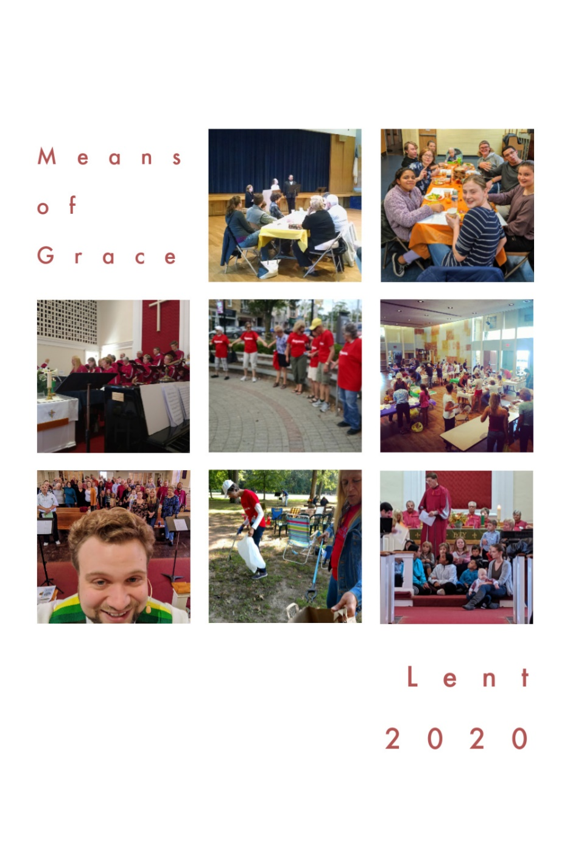

Week 5

What are “Means of Grace?”
John Wesley taught that God's grace is unearned and that we are not to be idle waiting to experience grace but we are to engage in the means of grace. The means of grace are ways God works invisibly in disciples, hastening, strengthening, and confirming faith so that God's grace pervades in and through disciples. As we look at the means of grace today, they can be divided into works of piety and the works of mercy.
Works of Piety
Individual Practices – reading, meditating and studying the scriptures, prayer, fasting, regularly attending worship, healthy living, and sharing our faith with others
Communal Practices – regularly share in the sacraments, Christian conferencing (accountability to one another), and Bible study
Works of Mercy
Individual Practices - doing good works, visiting the sick, visiting those in prison, feeding the hungry, and giving generously to the needs of others
Communal Practices – seeking justice, ending oppression and discrimination (for instance Wesley challenged Methodists to end slavery), and addressing the needs of the poor You are invited to engage in many of these means of grace during this season of Lent! Each Sunday, be sure to pick up this weekly devotional as we seek to grow more fully in God’s transformational love!

Discover more ways to engage in Lent online!

Weekly reflection videos: www.facebook.com/cranfordumcnj

Lent Photo-A-Day: @cranfordumc on Instagram

Website: www.cranfordumc.com

And, of course, Sundays at 10AM!
Monday: Scripture
Scripture: “Jesus wept.” John 11:35
Reflection: The assigned reading for this past Sunday is the story of Lazarus. It’s a 45 verse reading, which is exceptionally long for lectionary texts which try to be short within reason. This story has so much to say, however, that they include it in its entirety. Pastors, find your best readers for this one!
There are many lessons to pull from the story of Lazarus, but for today, I want to fix our attention on the shortest verse of the 45, and depending on your translation, the shortest verse in the entire Bible; “Jesus wept.” In the story, Jesus’ friend, Lazarus, dies and Jesus raises him from the dead. Even though Jesus knows that Lazarus can and will live again, when face to face with the reality of death, Jesus breaks down. This is one of the most human moments of Christ as he grieves his friend. I believe it’s an important moment for us to see. Jesus shows us that emotions are okay.
We are all experiencing emotions as we social distance. If you’re like me, you’re trying to work hard enough that you can avoid really sitting with the fear and anxiety. We are trying to be strong for each other, for our children, for our partners, for our friends. But, dear ones, it is okay to experience our feelings. We need to grieve the loss of our daily routines, and the sacrifices of healthcare workers and others working to ensure that we are able to be supplied, and the plight of those who are ill. We still move forward, like Jesus, who moved on to the resurrection of Lazarus, but perhaps we only get to that place of new life by facing the loss of the moment.

Tuesday: Music
My hope is built on nothing less
Than Jesus' blood and righteousness
I dare not trust the sweetest frame
But wholly trust in Jesus' name
Christ alone; cornerstone
Weak made strong in the Savior's love
Through the storm, He is Lord
Lord of all
-Hillsong United
This remake of the classic Hymn, “Solid Rock” is a reminder of who is the foundation upon which we stand through thick and thin. Our hope is found in the resurrection, love, and grace of Jesus! Let us find our rest in this sure and ever-present knowledge as we continue to wisely engage the world in ways that are prudent to prevent the spread of COVID-19.

Sunday: Worship
We are continuing with our online worship until such a time as larger group gatherings are safe once again. Unfortunately, at the time of writing this (March 26th) we do not have a date for that day.
Fortunately for us, worship is not limited to our Sanctuary nor to Sunday mornings! We can worship God at any time and in any place, in fact, we are encouraged to live our entire lives as acts of worship. Try developing that as a mindset this week. What might it look like to wash the dishes as an act of worship? How do we spend time relaxing as giving praise to God? Can you really worship while taking out the trash?
Well, our worship begins with giving thanks to God. You can simply be thankful that there are dishes that need cleaning because they carried food! That’s worship! You can be thankful for the unwinding of the mind, body, and spirit that relaxation brings. That’s worship! You can be thankful that you are able to consume enough that it has produced trash, or be thankful for the ingenuity of recycling which better cares for creation! You guessed it, worship!
So, what are some ways that you are going to be in worship this week?

Saturday: Prayer
Prayer for Palm Sunday
God of the cross, tottering down the streets of Jerusalem on a donkey,
You are not the savior we expect.
We are happy to join the crowd, waving branches,
but not so sure we want to follow you through this Holy Week:
into the temple courts
into the upper room
into the Garden of Gethsemane
to the high priest’s house,
to the assembly of elders,
to Pilate,
to Herod,
to the place of The Skull,
to the foot of the cross.
We need you to go with us on this journey.
Grant us clear vision,
Courageous hearts,
Persistent steps.
Even though we know what this week will bring, we sing:
Hosanna, hosanna.
Save us, we beseech you! Amen.
~ written by Joanna Harader

Wednesday: Fasting
I’m not sure about you, but I hadn’t quite planned on giving up this much for Lent! The liturgical season is getting closer to its conclusion, but we could be continuing our new social norms for quite some time. It’s a forced fast from our normal activities in many ways. I do maintain, however, that there is meaning to be found here if we are able to reflect and pray in the midst of our discomfort.
I read a tweet earlier in the week that said, “Let’s not go back to normal. Normal wasn’t working.” In many ways, that finds an echo deep in my soul. How often have I written and spoken about the need for our collective cultural heart to be changed and healed? Hatred, racism, injustice, polarization, and physical and spiritual violence have abounded for too long. Is a forced break from routine a catalyst that we need to be disrupted enough to change? I sure hope so.

Thursday: Healthy Living
In these days when we might not be afforded the freedom of movement that we are accustomed to, it is very important to maintain healthy practices both for our physical and mental health. I know that Easter candy is on major discount because the holiday has basically been physically cancelled, but eating an entire bag of Reese’s eggs is not going to be helpful.
As you are able to shop or make lists for shopping, be sure to include healthy snack items that you can grab when those boredom hunger pangs come calling. Celery and peanut butter have been a go-to for me lately. I think there’s some nostalgia at play there. Veggies and humus are great, healthy snacks, almonds, and other less salted nuts can also provide a boost. Be sure to try drinking water instead of running to the pantry.
Half of temptation is opportunity. Those Reese’s eggs are going to be eaten eventually, so build up that will power to ignore them at the store. Okay, maybe just a small bag for the occasional treat and reward!

Friday: Sharing Faith
Keep on loving one another, my friends.
A great way that you can “share” your faith in this time of virtual church is to click “share” on our Sunday morning worship if you have a Facebook account. The same goes for our other videos and resources during th COVID-19 response.
If you like what we have been doing, share it with others! You never know who might need a message of encouragement from their place of quarantine!

